**Updating an M-Drive Selection Lookup Table**

**Instructions**

Before you begin, know that you should only have two possible lookup tables to update: the **M_Drives** Sheet, or the **Motor_BOM_Tool** Sheet. All other lookup tables are considered static and will almost never change. Details under the “All Lookup Tables” section on this document lists the lookup tables this process relies upon, in the very rare case they need to be altered. For the two main tables, the process is as follows:

2. Open the intended hyperlink to go directly to the correct Monday board. You need to be on the web version. The Monday App version does not work well with Excel exports.

4. Click the **three dots** in the upper right-hand corner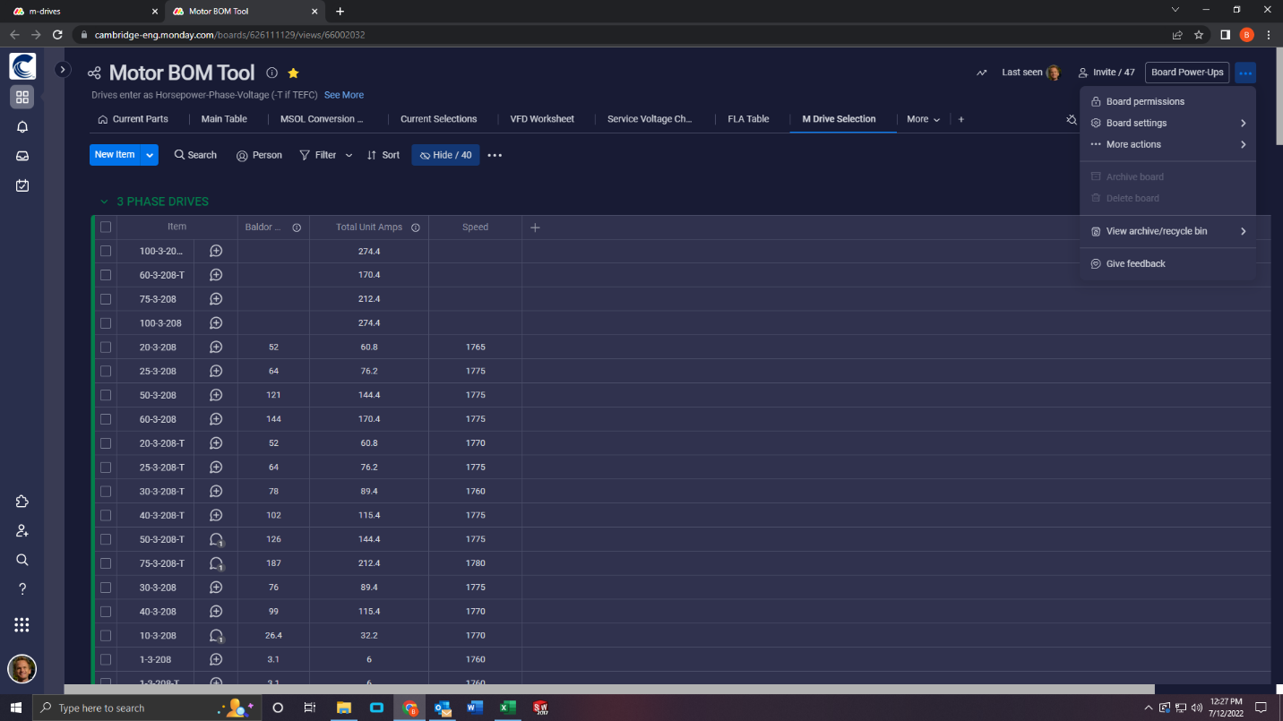

8. Wait for the download to complete.

9. Open your **Downloads** folder, and right click the file you just downloaded. Click **Rename**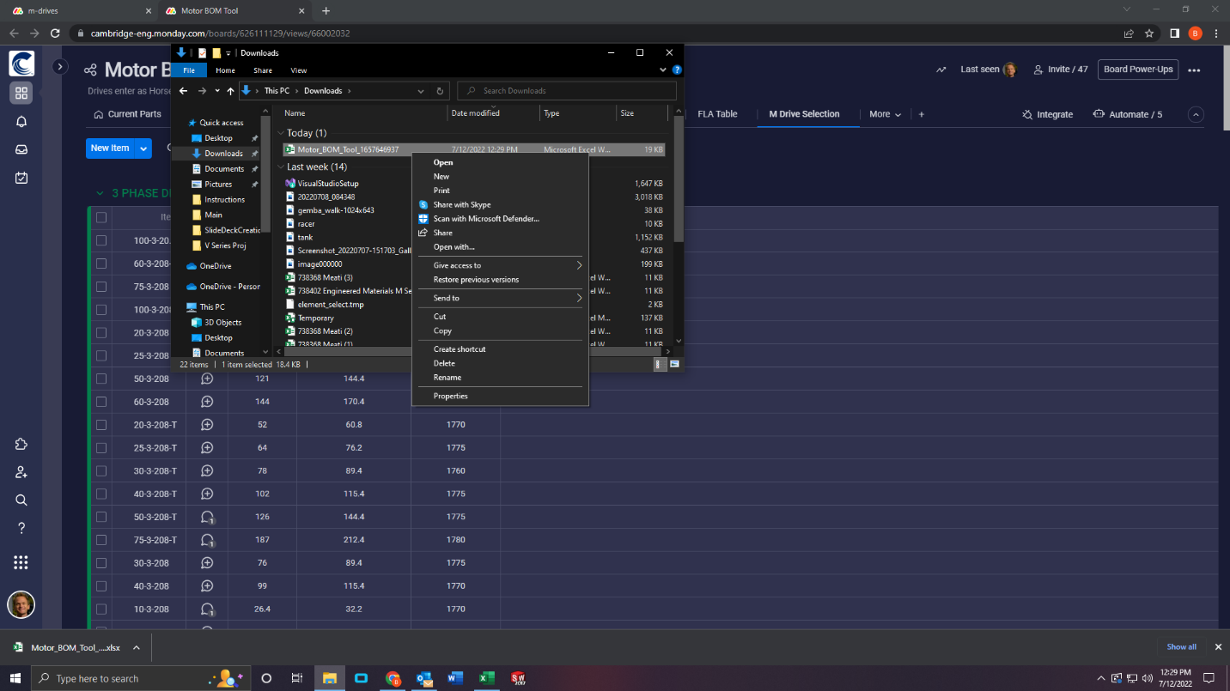

10. Rename the file to be either **Motor_BOM_Tool** or **M_Drives**, depending on the LUT you’re trying to replace. No other name will be accepted by the macros. Make sure you don’t swap the names either.A screenshot of a computer

13. Open **VFD_Parse**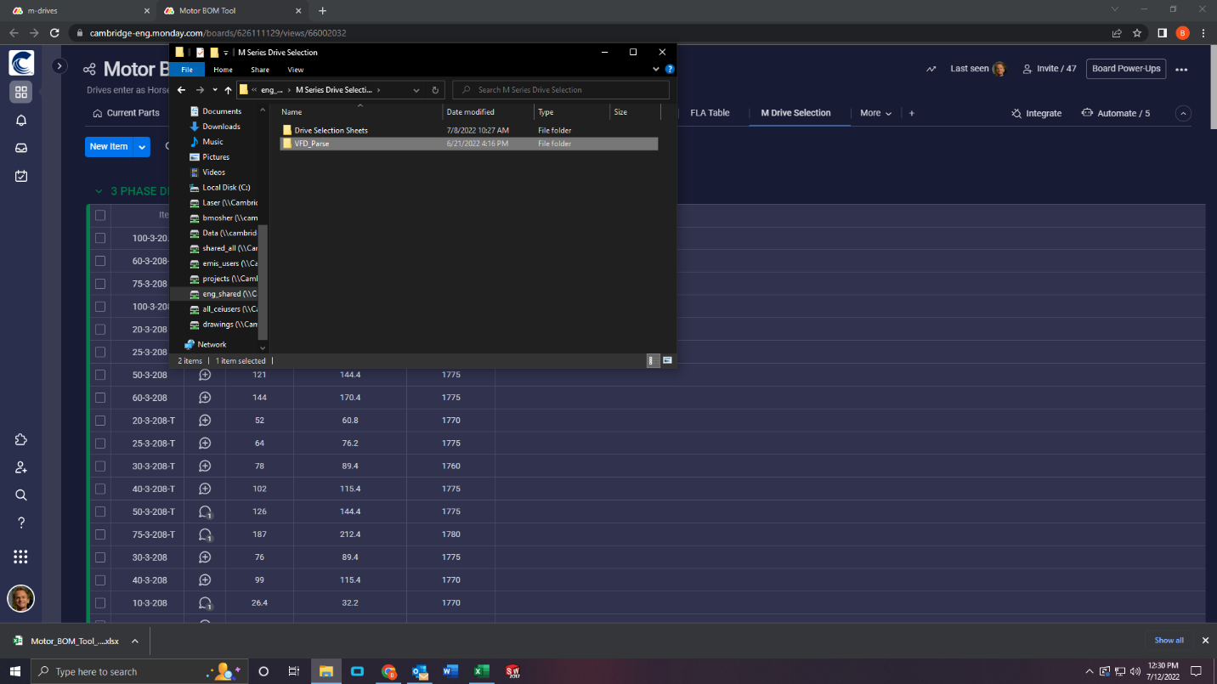

16. Click **Replace the file in the destination**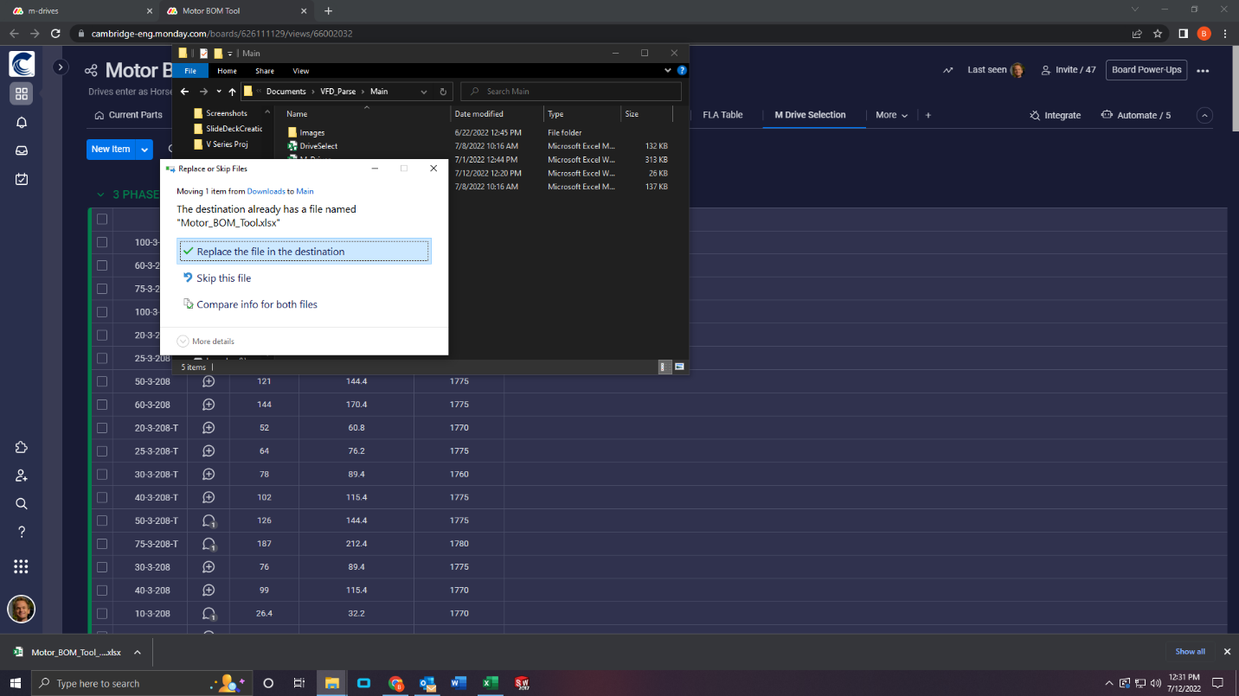

Strongly Recommended: Back up the file(s) you just changed to the GitHub Repository. Refer to instructions in **Backing Up the Code.docx.** Since you only changed these files, you only really need to push these files over their previous versions, not the entire folder.

Optional: Run a quick test (full Drive Selection) with any SMART order to ensure functionality is still there. No need to verify that the specific new entries work, you’re unlikely to find such a specific order. If for any reason the Drive Selection process does not work after the table change, **restore** the GitHub version that worked before. It may be helpful to “undo” the push of a bad table, as well.

NOTE: If the new M_Drives sheet contains more than around 3996 entries when newly updated, the macro code will need to be changed to include this range. You can use the **Visual Basic Editor** to find the macro set within the **DriveSelect** worksheet, and search for“M_Drives” to see where this range is. You should see a “With block” that has a field ranging from “A3:T4000”. It looks like this:

All you must do is change the row count under the T column to however many rows you need. Add about 250 extra for a buffer.

Example: To account for 4350 rows with an original tolerance of 4000 rows:

For any blank RPM values in **M_Drives**, the code will recognize this and skip to the appropriate column (default as the L_RPM column, as a backup). There’s no need to go in and fill every RPM field.

**All Lookup Tables**

* IVI Spring Calculation Tables: contained within the **IVI** sheet of the **VFD_Template**. Since these tables are self-contained, these should never go missing, but rarely might need updates. If you want updates to apply to all future Drive Selections, make sure to add an entry in accordance with all the rest in the table, and save over the old template. Use the backup template if anything goes wrong
* Max/Min Airflow Tables: contained within the **Sheet1** sheet of the **VFD_Template**. This is hidden, double click columns to make them appear, and then set the column width back to 0 once done editing to hide these again. Since these tables are self-contained, these should never go missing, but rarely might need updates. If you want updates to apply to all future Drive Selections, make sure to add an entry in accordance with all the rest in the table, and save over the old template. Use the backup template if anything goes wrong.
* Motor_BOM_Tool: contained within the **Motor_BOM_Tool**. This will be periodically updated if a new entry on the Monday board is needed. Follow the above procedure to update it.
* Drive List: contained within the **M_Drives.** This will be periodically updated if a new entry on the Monday board is needed. See step 5.a if the number of entries exceeds around 4000.
* VFD Reference Types: contained within the **Sheet1** sheet of the **VFD_Template**. This is hidden, double click columns to make them appear, and then set the column width back to 0 once done editing to hide these again. Since these tables are self-contained, these should never go missing, but rarely might need updates if new VFD Reference types emerge. If you want updates to apply to all future Drive Selections, make sure to add an entry in accordance with all the rest in the table, and save over the old template. You’ll need to expand the VFD section to search the range of the entire table, not just the old one. Use the backup template if anything goes wrong